The Navy League of Canada

Cornwell (Winnipeg) Branch

Financial Year End Report
for

January 1, 2016 to Dec 31, 2016

JTC Branch Financial Vision Statement
To provide sufficient and stable funding to operate the Corp successfully, and enable the Cadets to receive the tangible benefits that the Royal Canadian Sea Cadet Program offers.

Summary
This Report is for the Cornwell (Winnipeg) Branch financial year spanning from January 1 to December 31, 2016. The total Revenue generated for the financial year was $16,166 which was lower than the planned Budget of $17,135. The total Expenses incurred for the financial year were also much lower at $13,125, against a planned Budget of $19,950.
Both Revenue and Expenses were below the budgeted amounts and combined these produced a cash increase of $3,041. This amount is reflected as an increase in the closing Bank Balance from the previous year.
Cash assets in the Corp’s Chequing and Savings accounts totals $14,873 and the total amount in GICs is $14,824. Combined, this provides for total assets of $29,668..

Although the Expenses were well below budget, this can be attributed to two main line items. Both the Division Assessment and the Officers’ Mess Dinner expenses will flow into the next fiscal year. This does skew the financial statement, however the year end cash increase means that the Corp has sufficient assets to cover both. Overall the total assets will continue to ensure stability and opportunity for the next financial year.
Revenue
Overall, revenue of $16,166 was higher than the ten year average of $14,117. Key points to note on revenue are:
- DND LSA support was $4,450 (now on Direct Deposit)
- Bud, Spud and Beef fundraising Dinner deposit was $2,336
- 100 Year Anniversary raised $1,860 (total includes donations and fundraising)
- The Grey Cup Raffle Pool generated revenue of $1,721
- Officers’ Mess $1.380
- West Kildonan Legion provided support of $1,000 to the Corp
- Bingo revenue from the MB Rifle Association was $850
- The total donations were $814 (not including 100 Year Anniversary)
- GST of $756 (accumulate from the previous years)
- Canteen deposits were $674
- Christmas Dinner revenue was $135 as most was deposited in FY2017

Expenses / Special Purchases / Activities
Overall expenses at $13,125 were near the ten year average of $13,789. Key points to note on expenses are:
- 100 Year Anniversary expenses were $2,102, the bulk of which $2,006 was for the Challenge Coin initial purchase
- Training expenses were $1,855.
- Christmas Dinner costs were $1,827
- Range expenses were $1,550 which includes $1,500 was for the rental of a range.
- Sports expenses were $764
- Security checks were higher than average at $388 vs budget of $200, as a number of members came due in the same year
- Administration expenses were at $753, which included $218 for name tags, $231 for a printer and $296 for NL Insurance
- Corp ID items were $190, which was for Hat Embroidery
- Annual and AGM expenses were $172, plus $581 for updated trophy engraving
- The Manitoba Division 2016 Assessment was not incurred in the financial year and will be expensed in FY2017. This added to the year end surplus, however it will be result in a “double” payment in 2017.

Figure 1 compares the cumulative year end assets against the year-end expenses. This shows that revenue was higher and expenses lower than average for 2016, and there was a net change in assets of + $3,041, however this is skewed by the deferral of the MB Division payment and Officers’ Mess Dinner which will total $3,728. This is therefore not reflective of a trend. Also for consideration is the initial 100 Year Anniversary Challenge Coin purchase of $2.006, which will generate future revenue.

Fundraising
Fundraising generated 36% of the total Revenue, $5,757. The top fundraisers by profit generation were:
- Bud, Spud and Beef at $2,336
- Grey Cup Pool at $1.022
- West Kildonan Legion at $1000
- MB Rifle Bingo at $850

GIC
The GIC assets are in five separate funds with various terms. As the funds are renewed they are re-invested into 1 year terms. This has minimal effect on the rate of return and provides a sizable asset available each year if the funds are necessary for a special purchase or event. The total value of the GICs went from $14,463 in FY2015 to $14,793.

Sub-Accounts
Two sub-accounts were used last year to track specific areas of revenue and expense. They are:
- Officer’s Mess sub-account, value as of Dec 31, 2016 was $1,643. Note however that the Mess Dinner will be expensed in 2017.
- 100 Year Anniversary account, value as of Dec 31, 2016 was $42. Note however that the Challenge Coin purchase affected its value, but will add future revenue.

Canteen
The deposit slips and expense records for the Canteen were reviewed and found to be accurate and representative of the transactions.

Financial Requirements
The CRA has verified the Branch’s Registered Charity status and the 2016 Return has been filed. The GST Claims are now for six month periods and the backlog of previous claims has been processed. The Branch received as a lump a total GST deposit of $756.
The 2016 Annual Financial Audit was completed and has been submitted to the Manitoba Division. An error found in the previous year FY2015 (an Invoice accidentally paid twice) was corrected and reconciled in FY 2016.

Recommendations
A significant change to the DND LSA budget occurred in 2014, and continued in 2016 with additional funding available for sports and fitness related activities. The levels of addition funding through LSA should be verified for future years with the revisions to the Federal Budget
As depicted in Figure 1, the Branch is in a good financial position and additional training activities and major purchases can be considered in the next financial year.

Attachments
- STATEMENT OF RECEIPTS AND DISBURSEMENTS for Year Ending December 31, 2016
- STATEMENT OF ASSETS AND LIABILITIES for Year Ending December 31, 2016
- Receipt details for January 1 to December 31, 2016, ACU Community Builder Chequing Account
- Expense details for January 1 to December 31, 2016, ACU Community Builder Chequing Account
- Bank Statement showing account balances as of December 31, 2016.
- Financial Audit Letter FY 2016

Respectfully submitted,

E. Manchur
Branch Treasurer

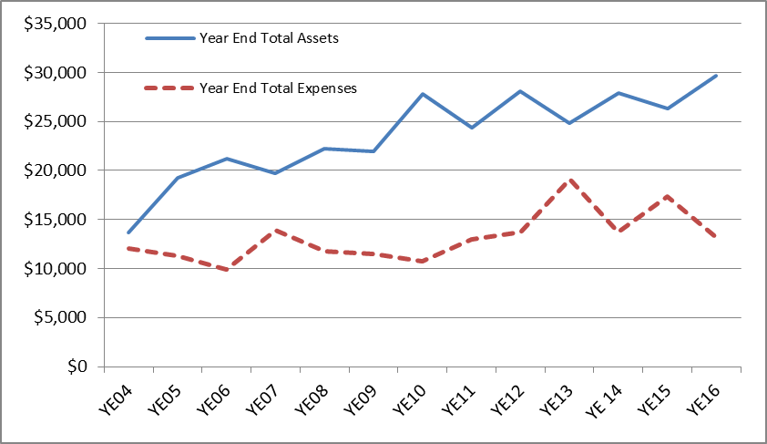
Figure 1, Total YE Assets and Expenses
Notes:
- Average 10 year Revenue = $14,117
- Average 10 year Expenses = $13,783
- Current Asset to Expense Ratio = 2.26

